English Reading

Fulfen Primary School adopts best practice from a range of research, resources and educational thinking to improve outcomes for all our children. At Fulfen it is our belief that every child regardless of background can leave our school with the ability to read fluently. We aim to achieve this by developing a love of reading as soon as children start school. We believe that children do not just become readers: fluency and enjoyment are the result of careful teaching and frequent practice. As a result, we ensure that reading is at the heart of everything that we do.

Our thoughtful and imaginative readers will acquire the skills to:
- have a love of books, striving to develop a personal collection of texts that they have read.
- link what they have read/are reading to their own experiences and their understanding of the wider world.
- want to read aloud, reading with expression and clarity – using tone, intonation and expression to show their understanding of a text.
- continuously make predictions regarding the text that they are reading, developing a wider collection of aspects to base predictions on as they develop through school.
- continually be justifying their thoughts and feelings on a text through specific examples from what they have read.
- ask regular questions to help develop their understanding of a text.
- continuously infer the feelings of a character and – as they develop their skill – begin inferring the thoughts, actions and motives.
- develop their own personal taste in books and texts, building their own opinions and values on specific text types.
- distinguish the differences between fiction and non-fiction texts, recalling features from each but acknowledging the importance of both text types.
- develop the skills of skimming and scanning to retrieve information from texts quickly – developing a recognition as to the importance of this skill for later life.
- be confident in summarising different parts of the text, taking modelling from their teachers to base their summarising skills.
- always consider the impact of what the author has written. How has the author made me feel as a reader? How can I implement this into my writing.
Please note that Greater Depth objectives are in bold for each year group.

READING CURRICULUM MAP

Reception | Autumn 1 | Autumn 2 | Spring 1 | Spring 2 | Summer 1 | Summer 2
Topic Themes
Non-Fiction |   Rocket Phonics  Reception Guided Reading is grouped in ability per attainment of GPCs.  Then appropriately pitched decodable texts are used.
Fiction
Poetry

Year 1 | Autumn 1 | Autumn 2 | Spring 1 | Spring 2 | Summer 1 | Summer 2
Topic Themes | Nurses - a comparison  Plants | Mapping the World  Plants | The UK  Materials | Changes through Time  Materials | Space Exploration  Animals inc Humans | Weather  Animals inc Humans
Texts for Guided Reading | Rocket Phonics  Year 1 Guided Reading is grouped in ability per attainment of GPCs.  Then appropriately pitched decodable texts are used. |  |  |  |  | Fiction  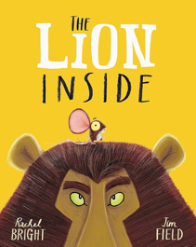  The Lion Inside By Rachel Bright

Year 2 | Autumn 1 | Autumn 2 | Spring 1 | Spring 2 | Summer 1 | Summer 2
Topic Themes | The Plague & Gunpowder Plot  Rosa Parks Materials | The UK | Australia  Animals inc Humans | Great Fire of London  Samuel Pepys | Local History  & Dr Johnson  Living Things & Habitats | Climate
Texts for Guided Reading | Fiction  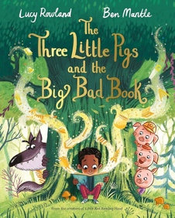  The Three Little Pigs and the Big Bad Book By Lucy Rowland  Non-Fiction  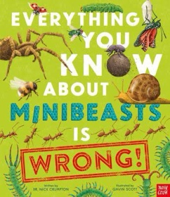  Everything You Know About Minibeasts is Wrong! By Dr Nick Crumpton  Poetry  When We Were Very Young and Now We’re Six  By A.A Milne  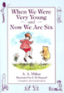 | Non-Fiction  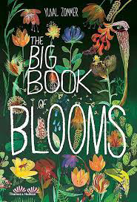  The Big Book of Blooms By Yuval Zoomer  Fiction  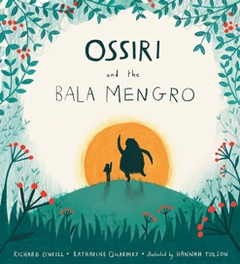  Ossiri and the Bala Mengro | Fiction  The Flower  By John Light  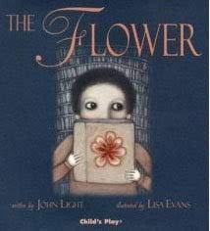  Fiction  The Black Book of Colour  By Menena Cottin  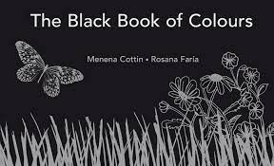 | Fiction  The Owl Who Was Afraid of the Dark By Jill Tomlinson  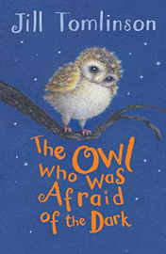  Non-Fiction  Creature Features  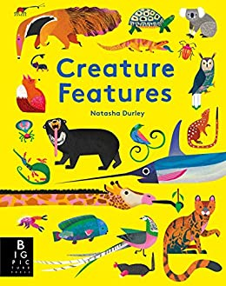  By Natasha Durley | Fiction  Albert Talbot Master of Disguise  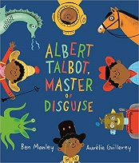  By Ben Manley  Fiction  The Tear Thief  By Carol Ann Duffy  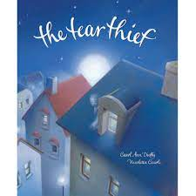  Non-Fiction  Little Leaders: Bold Women in Black History By Vashti Harrison  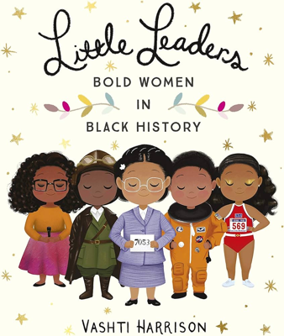 | Fiction  The Wonder  By Faye Hanson  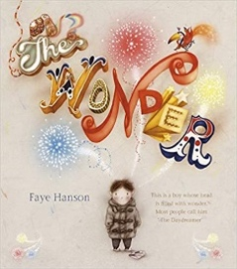  Non-Fiction  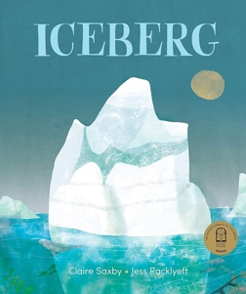  Iceberg By Claire Saxby

Year 3 | Autumn 1 | Autumn 2 | Spring 1 | Spring 2 | Summer 1 | Summer 2
Topic Themes | Stone Age | Volcanoes & Earthquakes | Maps around the World | Iron Age | Roman Impact on Britain | The UK
Texts for Guided Reading | Non-Fiction  The Street Beneath My Feet  By Charlotte Guillian  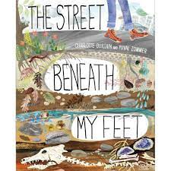  Fiction  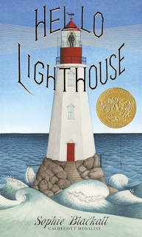  Hello Lighthouse By Sophie Blackall  Poetry  I Don’t Like Poetry (use a selection of poems)  By Joshua Seigal &  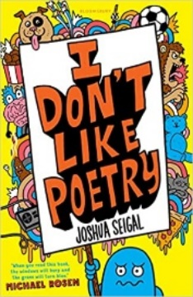 | Fiction  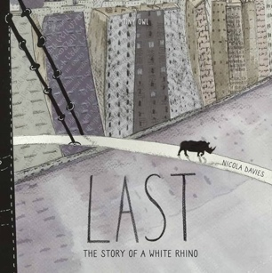  Last By Nicola Davies  Poetry  Lord Alfred Tennyson ‘The Eagle’.  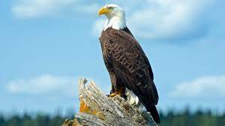  Non-Fiction  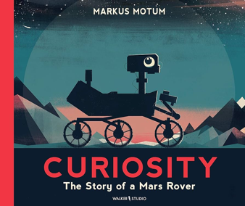  Curiosity: The Story Of a Mars Rover By Markus Motum | Fiction  Little Manfred  By Michael Morpurgo  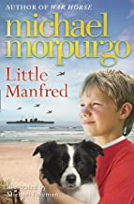  Non-Fiction  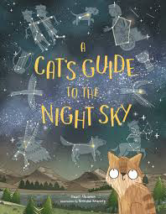  A Cat’s Guide To The Nights Sky By Stuart Atkinson | Fiction  Iron Man  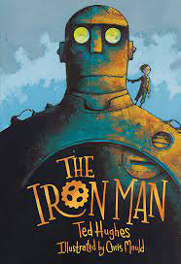  By Ted Hughes  Non-Fiction  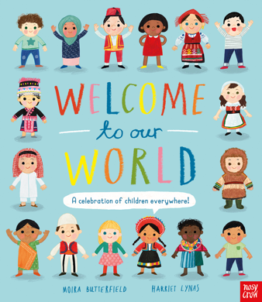  Welcome To Our World: A Celebration of Children Everywhere! By Moira Butterfield | Fiction  The BFG  By Roald Dahl  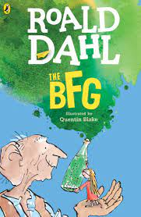  Poetry  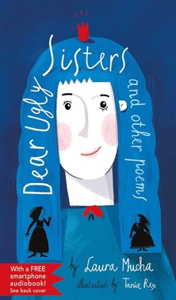  Dear Ugly Sisters and Other Poems By Laura Mucha  Non-Fiction  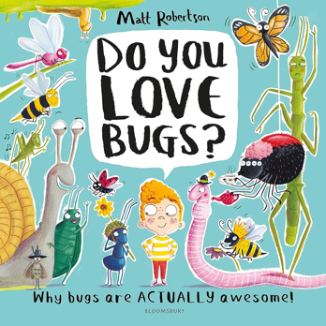  Do You Love Bugs? By Matt Robertson

Year 4 | Autumn 1 | Autumn 2 | Spring 1 | Spring 2 | Summer 1 | Summer 2
Topic Themes | Anglo Saxons | European Study | Local Geography Study | Egyptians | Local History –  Coal-mining | Water Cycle & Climate Change
Texts for Guided Reading | Non-Fiction  The Anglo-Saxons: Clever Ideas and Invention from Past Civilisations  By Izzi Howell  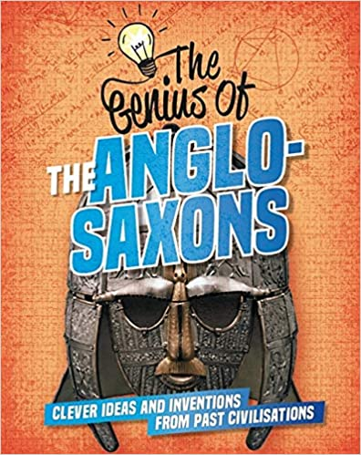  Poetry  Tiger, Tiger Burning Bright  By Fiona Waters  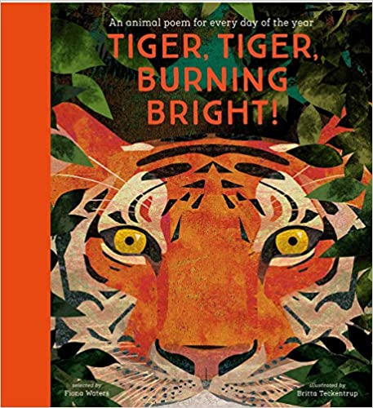 | Fiction  There’s a Boy in the Girls Bathroom  By Louis Sachar  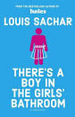  Non-Fiction  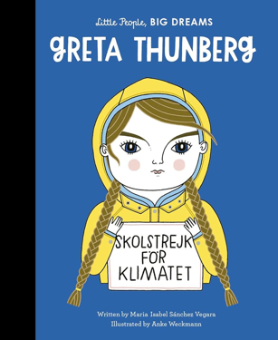  Greta Thunberg (Little People Big Dreams) By Maria Isabel Sanchez Vegara | Poetry  The Lost Spells  By Robert Macfarlane  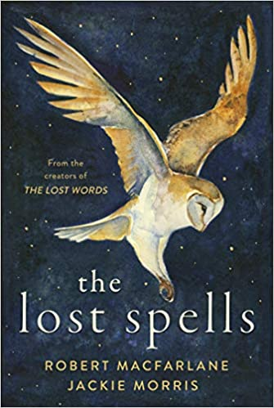  Non-Fiction  We’re All Wonders By R.J Palacio  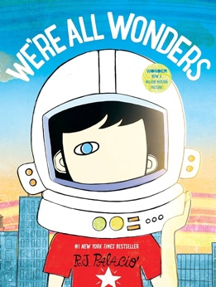 | Fiction  Varjak Paw  By SF Said  .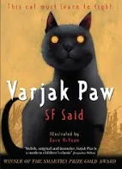  Poetry  Where My Wellies Take Me By Michael Murpurgo  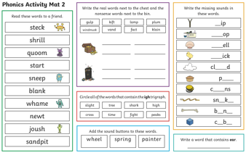  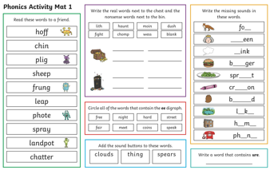  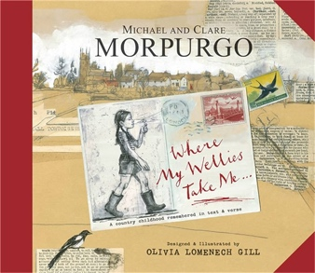  Non-Fiction  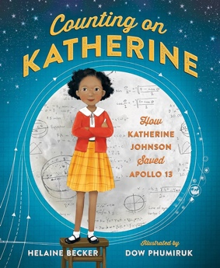  Counting On Katherine By Helaine Becker | Fiction  Charlotte’s Web  By E. B White  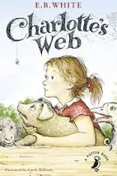  Non-Fiction  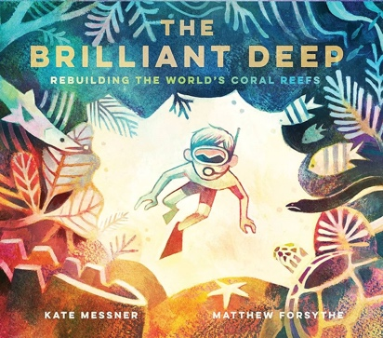  The Brilliant Deep: Rebuilding the World’s Coral Reefs By Kate Messner  Fiction  Orion in the Dark  By Emma Yarlett  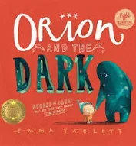

Year 5 | Autumn 1 | Autumn 2 | Spring 1 | Spring 2 | Summer 1 | Summer 2
Topic Themes | Vikings | Rivers and Mountains | North American Study | Ancient Greeks | Mayan Civilisation | Study of Mexico
Texts for Guided Reading | Non-Fiction  Vikings  Fiction  The Journey  By Francesca Sanna  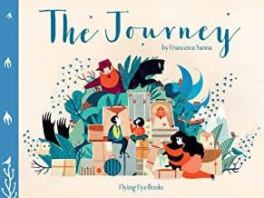 | Poetry  Spaced Out  By James Carter and Brian Moses  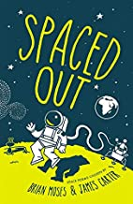  Fiction  A Christmas Carol  By Charles Dickens  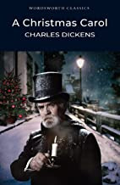  Non-Fiction  Becker Real Life Mysteries By Susan Martineau  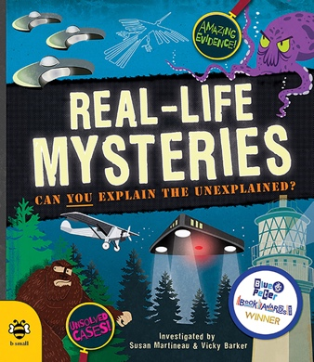 | Poetry  Fire Burn, Cauldron Bubble: Magic Poems  By Paul Cookson  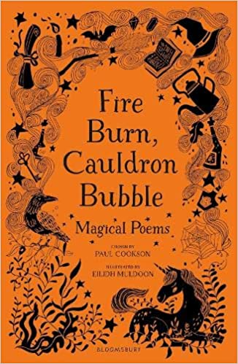  Non-Fiction  50 Adventures in the 50 States  By Kate Siber and Lydia Hill   | Fiction  The Explorer  By Katherine Rundell  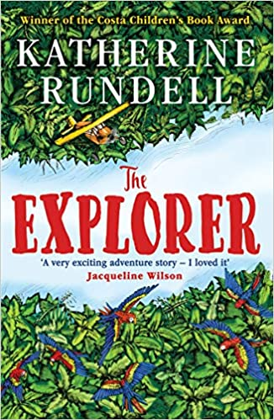  Non-Fiction  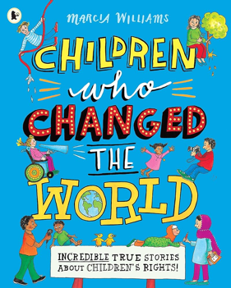  Children Who Changed The World By Marcia Williams | Fiction  Rain Player  By David Wisniewski  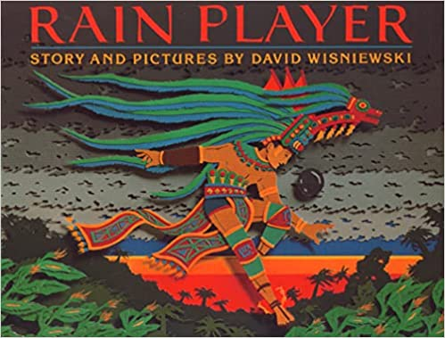  Fiction  The Viewer  By Gary Crew and Shaun Tan  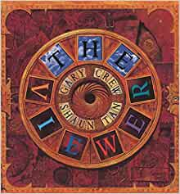  Non-Fiction  Young, Gifted and Black By Jamia Wilson  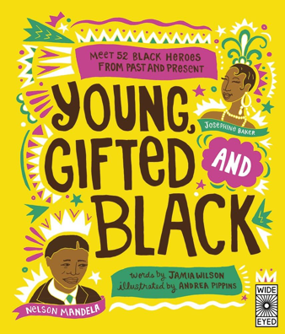 | Fiction  The Girl of Ink and Stars  By Kiran Millwood Hargrave  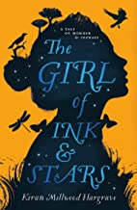  Poetry  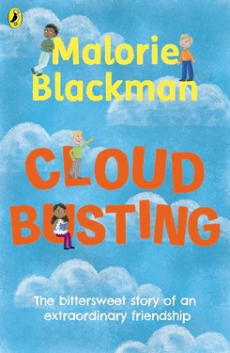  Cloud Busting By Malorie Blackman  Non-Fiction  Good Night Stories For Rebel Girls By Elena Favilli  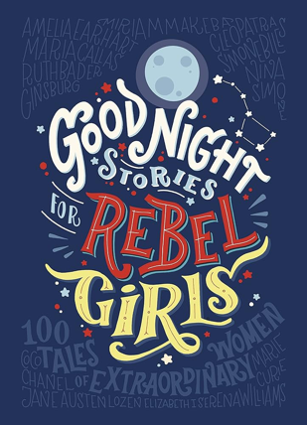

Year 6 | Autumn 1 | Autumn 2 | Spring 1 | Spring 2 | Summer 1 | Summer 2
Topic Themes | Victorians | Ocean Currents and Marine Biomes | Climate Zones | Own Projects | WW2 | South America
Texts for Guided Reading | Fiction  Holes  By Louis Sacher  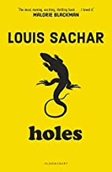  Poetry  Still I Rise  By Maya Angelou  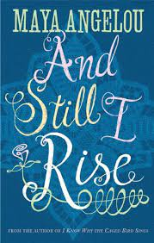  Non-Fiction  The Humans: Ancient Civilisations and Astonishing Things They Taught Us By Jonny Marx |  | Fiction  Cogheart  By Peter Bunzi  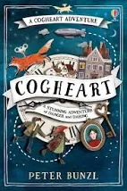  Non-Fiction  A Galaxy of Her Own: Amazing Stories of Women in Space By Libby Jackson  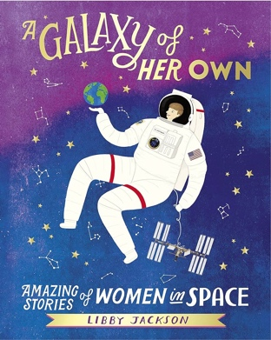 | Fiction  Letters From the Lighthouse  By Emma Carroll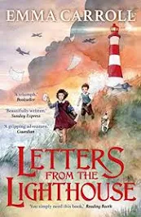  Non-Fiction  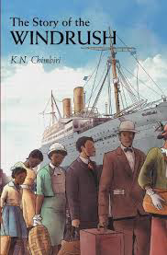  The Story of the Windrush By K.N.Chimbiri | Fiction  Shackleton’s Journey  By William Grill  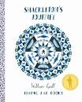  Non-Fiction  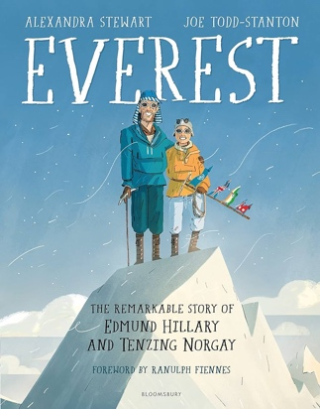  The Remarkable Story of Edmund Hillary & Tenzing Norgay By Alexandra Stewart | Fiction  Trash  By Andy Milligan  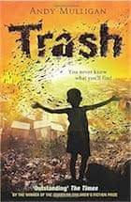

Reading Progression Map KS1
Year | Decoding/Fluency | Retrieval | Prediction |  | Inference | Questioning | Summarising |  | Clarifying
Year 1 | In Year 1, children should read confidently by decoding - using the sounds they have been taught so far.  They should also have a growing number of words they can read on their own instantly. | Based on what they have just read or listened to, children should be able to answer simple questions about what happened in the story. | When making predictions, children in Year 1 should be making them based on the story and on their own life experience.  They can begin to explain these ideas verbally or though pictures. |  | Children should be making inferences about characters’ feelings using what they say and do in a book to help justify their ideas. | Children can generate literal recall questions.  They are taught how to ask questions before, during and after reading by the teacher and this should be developed regularly throughout the year. | Children should be retelling and ordering events from the text.  They should also begin to discuss how events in books are linked. |  | Children discuss new word meanings and link them to words they already know.
 | Key Questions |  |  |  |  |  |  | Vocabulary
 | What has the character said that makes you think this?  How do you think the character is feeling? Why?  What do you think might happen next?  Have you got any of your own questions about the book?  Have you had any of your own experience like the character in the book? |  |  | Can you give examples from the text to explain why you think this?  Why do you think the character chose to do this? Can you find anywhere in the text to show this?  What is your favourite type of book and why?  Can you find any extra information from this non-fiction text?  Can you retell the story and show your understanding of the characters? |  |  |  | Guess, predict, feelings, speech, decoding, guess, order, events, links, recall, beginning, middle, end.

Year | Decoding/Fluency | Retrieval | Prediction |  | Inference | Questioning | Summarising |  | Clarifying
Year 2 | Children in Year 2 should be reading at a speed of 90 words per minute.  Children should also develop expression when reading aloud, particularly where characters are speaking in a story. | Children in Year 2 should have regular chances to read on their own; and should then explain their understanding of reading by answering simple questions based on what they have just read. | Children will make predictions using their own knowledge as well as what has happened in a text so far to make logical predictions.  These predictions must be accompanied by explanations. |  | Children should make inferences about characters’ feelings using what they say.  However, developing from Year 1, they should infer basic points and begin, with support, to pick up on more subtle references. | Children generate literacy recall questions of their own which go with the text they are reading before, during and after reading.  Children can use their own question words and begin to be able to change their questions as they progress through the text | Children need to be retelling and ordering events from the text. They also should begin to discuss how events are linked together.  Developing from Year 1, they are able to focus on the main content of the story and use this as a basis for their activities. |  | Children begin to find the meaning of new words using the context of the sentence.  They use pictures to help support this skill.
 | Key Questions |  |  |  |  |  |  | Vocabulary
 | What has happened in the story so far?  How can you use what has happened in the story to justify your prediction?  How can we order this book? What is the main part of the story?  Do you have any questions about the text?  How do you think the character is feeling?  What do you think the author is trying to tell us? |  |  | Can you independently infer character’s feelings?  Based on what you have read so far, how are you sure that your prediction is going to come true?  What links can you find with this book and other books you have read?  Can you show your understanding of the character dialogue through your tone and intonation? |  |  |  | Predict, order, question, main part, links, expression, explanation, prediction, retell, order, meaning
Reading Progression Map LKS2

Year | Decoding/Fluency | Retrieval | Prediction |  | Inference | Questioning |  | Summarising | Clarifying
Year 3 | Children need to apply their growing knowledge of root words, prefixes and suffixes, both to read aloud and to understand the meaning of new words.  Also, children should read further exception words, noting the unusual correspondences between spelling and sound. | In Year 3, Children will begin to use quotations from the text to answer questions and justify opinions.  Also, the skill of ‘skim and scan’ will be started to retrieve details. | Children will use relevant prior knowledge to make predictions and justify them. They will also be taught the skill of using information from the text to form further predictions, realising the importance of justifying their ideas with key examples from what they have read. |  | Children will infer characters’ feelings, thoughts and motives. They will also begin to justify them by referencing specific points in the text. | Year 3 children should be confident in asking questions to deepen their understanding of the text.  Children should also begin identifying different themes of stories (good, evil/love, hate etc.) and use this to develop their own questions of the text. |  | Children will learn to distinguish between the important and less important information in a text.  They will also be able to give a brief verbal summary of what they have read.  Teachers begin to model how to record  summary writing, providing children with opportunities to do the same. | Children begin to find the meaning of new words using substitution within a sentence.
 | Key Questions |  |  |  |  |  | Vocabulary
 | What evidence from the text can you find to justify your opinion?  Why would we skim the text to find clues?  Why do you predict that? Can you use life experience and evidence from the text to help justify?  What themes can you find from the text? |  |  | What is the relationship between the poet and the contents of the poem?  How does the writer set out their writing and what impact does this have on the reader?  How does the figurative language used convey meaning to the reader?  Can you find any deeper meaning to that of the author’s original intentions? |  |  | Themes, convention, prior knowledge, justify, evidence, example, feelings, motives, thoughts.

Year | Decoding/Fluency | Retrieval | Prediction |  | Inference | Questioning |  | Summarising | Clarifying
Year 4 | Children will read silently and aloud, reading fluently enough to gain the meaning from the text. Children will also re-read where necessary and know the benefit of doing so.  Children can use expression confidently when  reading aloud. | Children must show confidence with the skill of skimming and scanning texts to record details.  They must also show a fluency in using quotes from the text in supporting their answers to questions. | In Year 4, pupils will use relevant prior knowledge as well as details from the text to form predictions and to justify them.  They will also need to be taught to monitor these predictions and compare  them with the text as they read on. |  | Children will infer characters’ feelings, thoughts and motives from their stated actions and previous references from the text.  They will also consolidate the skill of justifying them using a specific reference point in the text. | Year 4 pupils will generate a variety of questions – recall and inferential - and questions about the deeper meaning of a text. This will help them with their deeper and further understanding of a text.  Children will develop the idea of story themes from Year 3, and use this to help answer questions based on prediction and characters’ motivations and actions.  Story themes will develop further to areas such as courage and obstacles to overcome. |  | Children will use skills developed in year 3 to write a brief summary of main points, identifying and using important information.  They will also use their skills of prediction and inference to assist their summaries. | Children will find the meaning of new words using the context of the sentence they have read.  They should also link new words to other words they already know.
 | Key Questions |  |  |  |  |  | Vocabulary
 | What is the purpose of skimming and scanning the text?  What do the motives and actions of the character show?  Was your prediction correct? What clue was given for this?  Can you find a reference of the text to help answer this question?  What are further themes of books we have read? |  |  | Can you recognise areas of Year 4 GPS that are used in this text? What impact does it have and how can you use this in your own writing?  Why is there bias in persuasive writing? What impact do you think this has on the reader?  How do the fictional and factual accounts of historical accounts compare? Why do you think this?  How can you use your understanding of the text to consider your audience when reading aloud? |  |  | Themes, convention, courage, action, prediction, justification, details, skimming, scanning, context, link, reference, summary.

Reading Progression Map UKS2

Year | Decoding/Fluency | Retrieval | Prediction |  | Inference | Questioning |  | Summarising | Clarifying
Year 5 | Children in Year 5 can read silently and recognise words automatically.  They can also group words quickly to help them gain meaning from what they read.  Fluent Year 5 readers will read aloud effortlessly and with expression. | Year 5 children will locate information accurately through skimming to gain an overall sense of the text.  They will also scan a text to gain specific information to help answer questions.  Using the skills of skimming and scanning, Year 5 pupils will identify sections of text to read more carefully and re-read/ read on when appropriate. | Year 5 children will make regular and increasingly plausible predictions as they read, modifying their ideas as they read the next part of the text.  Every prediction that they make must be based on relevant information from the text. |  | Inference in Year 5, involves understanding what is implied about characters and making judgements about their motivations and attitudes from the dialogue and description. | Children will actively generate a variety of questions to focus the reading and adjust questions in light of evidence from the text.  Adults model the use of critical thinking skills that take the discussion deeper and beyond the text. |  | Children should begin to make connections between information across the text and include this information in their written summaries.  Children will also ‘read around the word’ and explore its meaning in the broader context of a section or paragraph. | In persuasive writing and other texts investigate how language is used to present opinion.  Distinguish between fact, opinion and fiction in different texts, e.g. biography, autobiography, argument
 | Key Questions |  |  |  |  |  | Vocabulary
 | How does the dialogue show a deeper meaning of the character/text?  What group of words show the meaning of the text?  What do the characters’ motivations and attitudes show about the text?  Can you express your own opinions of the text by using evidence and clear explanations?  After reading further, can you adapt your own opinion of the text? What changed your opinion? |  |  | What are the similarities and differences between different authors writing about the same topic?  How can you effectively summarise the text and why is this an important reading skill?  Can you infer meaning by using your own life experiences?  Can you identify the shift in formality in a text? How does this impact the reader? |  |  | Specific information, predict, judgement, motivation, attitude, dialogue, summarise, summary, fact, opinion, biography, autobiography, context

Year | Decoding/Fluency | Retrieval |  | Prediction | Inference | Questioning |  | Summarising | Clarifying
Year 6 | Year 6 children’s reading sounds natural, as if they are speaking. They will read aloud different texts, including poetry and prose, discussing and drawing out similarities and relationships of theme, format and language. They will also read aloud to interpret poems or stories where meanings are conveyed directly and implied, varying the performance to convey meaning to an audience. | Children will evaluate the value of a text for an identified purpose, drawing on information acquired by skimming and scanning. Children will also carefully read sections of texts to research information and to answer questions. Using evidence from across a text, children will explain events or ideas. Year 6 pupils will also Identify similarities and differences between characters, places, events, objects and ideas in texts. Children will read information from texts and evaluate its reliability and usefulness. |  | Year 6 pupils will make plausible predictions and explain what they are basing them on. They will also discuss how and why they need to modify their predictions as they read on. | Children will understand what is implied about characters through the way they are presented, including through the use of a narrator or narrative voice, explaining how this influences the readers’ view of characters. | Children will ask questions to clarify and explore their understanding of what is implied in the text. They will also locate resources for a specific research task, identifying key questions to be investigated, the usefulness of the information source, and deciding how best to record and present the information. They will also research questions in the light of initial findings. |  | Summaries will be regular and will be based on what the children have read, linking their summary to previous predictions about the text. They will update their ideas about the text in the light of what they’ve just read. Year 6 pupils will summarise ‘evidence’ from across a text to explain events or ideas. They will also summarise their current understanding about a text at regular intervals. | In autobiography and biographical writing, and in texts written for mixed purposes (e.g. leaflets that are both information giving and persuasive), children will distinguish between fact, opinion and fiction. In non-fiction texts, children will distinguish between explicit and implicit points of view. Children will also collect unfamiliar vocabulary from texts they have read, define meanings and use the vocabulary when recording ideas about the text. Collecting and defining of technical vocabulary will be based on the language they have met in other subjects, e.g. developing subject or topic glossaries.
 | Key Questions |  |  |  |  |  |  |  |  | Vocabulary
 | Can you recognise the vocabulary from any further reading/subject?  What similarities and differences can you spot between the themes of the text?  How can skimming and scanning help us answer questions?  What questions would require skimming and scanning?  What are the differences and similarities between characters/places/events/objects/ideas in a text? |  | What is the purpose of the effect on the reader?  Can you independently express your personal opinions, views and responses to the text by consistently using key evidence?  What is the impact of the author and how does it impact your own feelings? Have you had a similar reading experience?  Can you compare and contrast the different poetic styles by writers and give specific examples from the texts?  What questions instantly came to your mind when reading this text? |  |  |  | Can you confidently explain meaning, messages, moods, feelings and attitudes in poetry and prose?  Can you independently refer back to the text to justify your thoughts?  Can you offer an alternative prediction to your own and consider why other readers may predict this?  Can you recreate the author’s work into your own style?  How do you think the author could adapt his choice of grammar, vocabulary and punctuation to improve their writing? |  |  | Vocabulary, impact, clarify, explore, value, implication, information, resources, vocabulary, purpose, research, presentation, narrative voice, differences, similarities, point of view, fact, opinion.

