Itinerary of the week EYFS in Club  W/C 07/10/24 | Monday | Tuesday | Wednesday | Thursday | Friday
Activities -(Afterschool)  Weekly planning  - Healthy Eating /The Very Hungry Caterpillar  Provision includes –  Arts/Crafts  Literacy  Construction  Malleable  Fine Motor  Small world  Role play  Child choice/interests  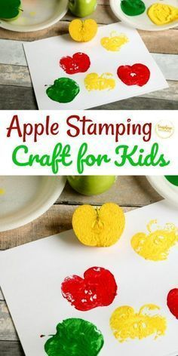  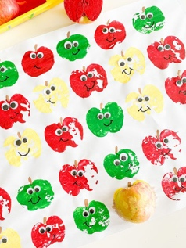  Area s of learning | Arts/Crafts– Apple printing  PSED,CL,PD,UW,EAD  Literacy- selection reading books  Fine Motor  Geo Metric pattern boards  Malleable – Playdough  Role play/Small world –  - Peppa Pig  - Sea Animals Pirates  - Home corner  Construction – Flowers  Child choice/interests –  Home Corner | – Arts/Crafts Apple Printing  PSED,CL,PD,UW,EAD  Literacy  -selection reading books  Fine Motor  Geo Metric Pattern Boards  Malleable – Playdough  Role play/Small world –  - Peppa Pig  - Sea Animals Pirates  - Home corner  Construction – Flowers  Child choice/interests –  Home corner | – Arts/Crafts Apple Printing  (PSED,CL,PD,UW,EAD )  Literacy  – selection reading books  Fine Motor  Geo Metric Pattern Boards  Malleable – Playdough  Role play/Small world –  - Peppa Pig  - Sea Animals Pirates  - Home corner  - Construction – Flowers  Child choice/interests – Home corner | – Arts/Crafts Apple Printing  PSED,CL,PD,UW,EAD  Literacy  – selection reading books  Fine Motor  Geo Metric Pattern boards  Malleable – Playdough  Role play/Small world –  Peppa Pig  - Sea Animals Pirates  - Home corner  Construction – Flowers  Child choice/interests – Home corner | New week
 | Monday | Tuesday | Wednesday | Thursday | Friday
Active Time / Songs/Circle games  Pre School /Reception Intentions  Why is it important to stay healthy ?  What is your favourite Fruit /Vegetable  What happens if we don’t eat healthy ? / Build new vocab – ( fruit /vegetbles,1 of your 5 a day, energy, happy, germs ) | Story – The Very Hungry Caterpillar | Action Songs | Story – The Very Hungry Caterpillar | Action Songs

