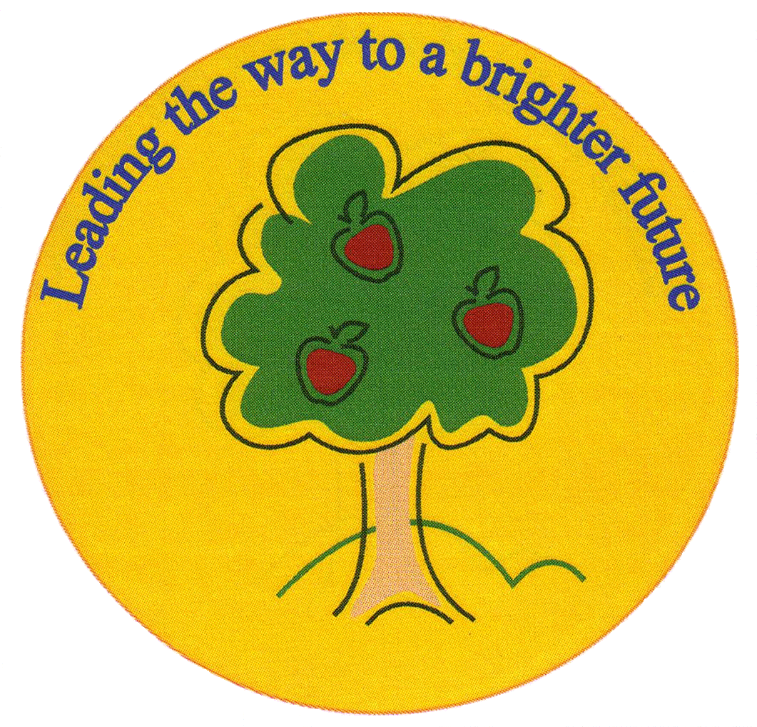
Fulfen Primary School

Rugeley Road
BURNTWOOD
Staffordshire
WS7 9BJ

Telephone: 01543 226070
E-mail: office@fulfen .staffs.sch.uk

14th September 2018

Dear Parents/Carers

On Thursday 11th October, we will be taking the children in Year 5 to the National Space Centre in Leicester to complement their Space topic. During the day, the children will be looking around all parts of the Space Centre, enjoying six hands on galleries, interactive challenges and watching a 30 minute show inside the Sir Patrick Moore Planetarium. We have also booked a workshop where the children will take on the role of robotics engineers, programming a rover to complete challenges across the surface of Mars!

We are asking for a voluntary contribution of £20.00. This covers the cost of the coach, admission to the centre and the Mars Rover Workshop. However, if we do not receive enough voluntary contributions, unfortunately the trip may need to be cancelled.

Payment should be made on ParentPay before Friday 5th October.

We will be departing from school at 9.00am and returning at approximately 5:30pm in order to have as much time at the Centre as possible. Please could you provide your child with a packed lunch and a drink (no fizzy pop please or glass bottles please). Children are to wear school uniform as normal.

Yours sincerely

Mrs Shermer Miss Morgan Mrs Connock

Year 5 Visit to the National Space Centre Leicester

Childs Name__________________________________

Class___________________

I give permission for my child to visit the National Space Centre on Thursday 11th October 2018

I have paid £20 on ParentPay towards the cost of the trip.

Signed___________________________ Date________________________

