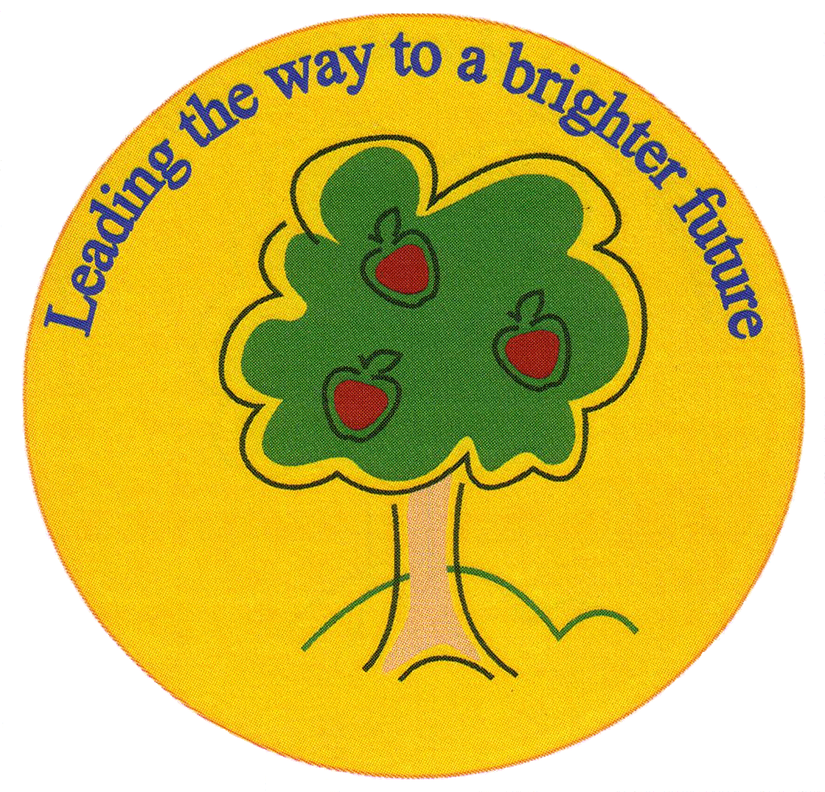
Fulfen Primary School

Rugeley Road
BURNTWOOD
Staffordshire
WS7 9BJ

Telephone: 01543 226070
E-mail: Office @fulfen.staffs.sch.uk

Headteacher: Miss Jane Davies

Dear Parents/Carers,

As the phonics screening test is fast-approaching, we would like to engage the Year 1 children further by having a phonics day on Wednesday 1st May 2019.

Children are welcome to dress up as their favourite phonics character for example;

- Clown upside down ow ow ow
- Busy busy bee ee ee ee
- Boy with a toy oy oy oy
- Queens run quickly qu qu qu
- Huge claw aw aw aw (Monster)
- Girl in a whirl ir ir ir

These are just a few ideas, please see the Phonics mat attached for more costume inspiration!

Throughout the day, the children will be involved in many activities which will allow them to practice their phonics knowledge and challenge them with new sounds and tricky words.

If you have any questions, please do not hesitate to contact us.

Many thanks for your continued support,

The Year 1 team

