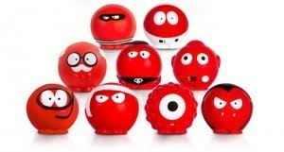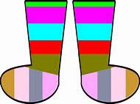

Fulfen are supporting Comic Relief again this year on

FRIDAY 15th MARCH

Its Non Uniform Day

We are asking children to come to school in “Silly Socks”

They can be odd socks, spotty socks stripy socks or

generally just very “silly socks”. They can wear them under their trousers or over their trousers , over their tights or leggings or on their hands if they wish. The sillier the better!

Please bring in a £1 donation for Comic Relief to

Participate. Thank you