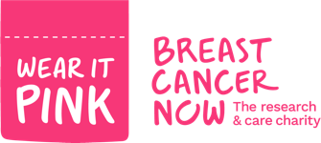
Friday October 22nd 2021
On Friday 22nd October, Fulfen Primary School will be having a non-Uniform day. This term, we are not only helping our school fund but will also be donating money to Breast Cancer Now.
Breast Cancer Now’s, ‘Wear It Pink’ day is one of the biggest fundraising events in the UK. Taking place during Breast Cancer Awareness month, thousands of amazing people ‘wear it pink’ in their communities, schools or work places for the UK’s largest breast cancer charity, Breast Cancer Now.
Please encourage your child to wear something pink for the day. It can be socks, hair bands, dresses, shorts, T shirts, jumpers or anything pink really!
We would like a donation of £1 which will be shared between our school fund and this amazing charity. They can bring their donations into school and give them to their class teachers.
Thank you very much for your support.

Yours sincerely

Miss Davies

