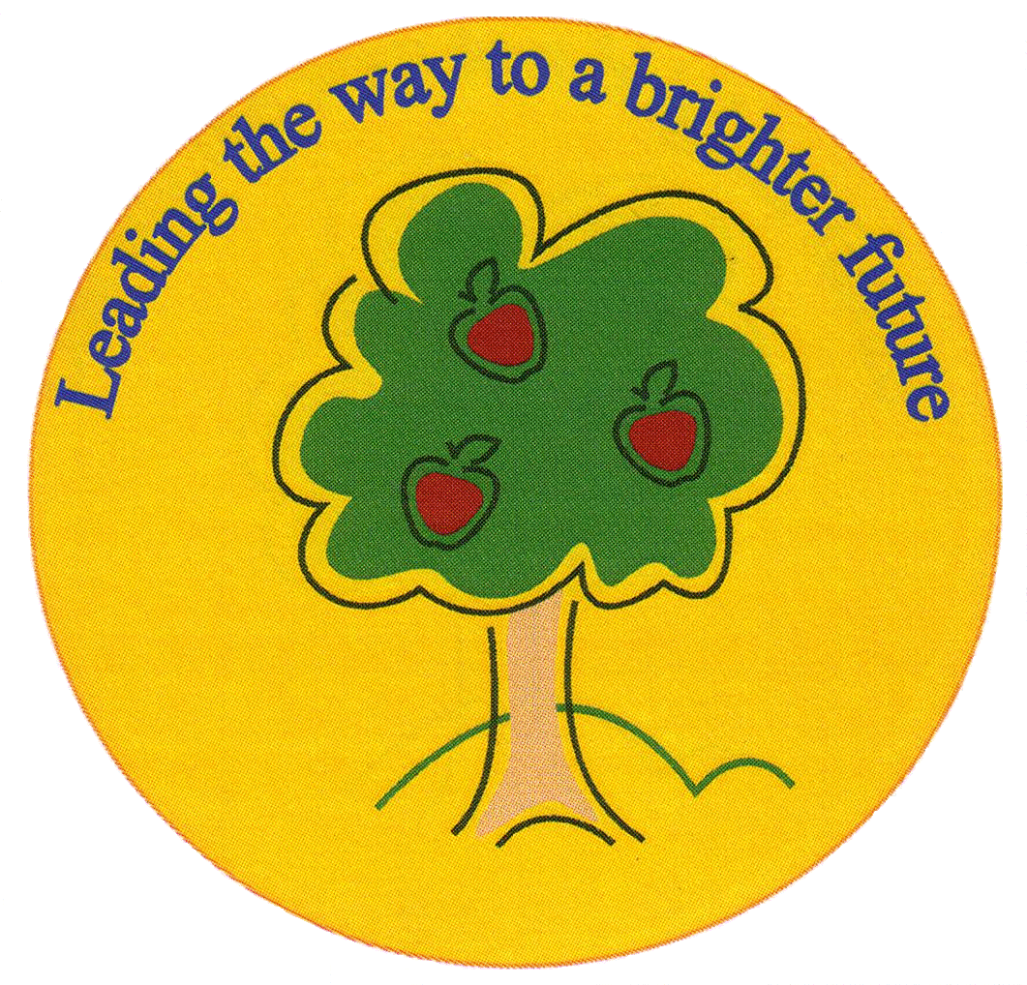
Fulfen Primary School

Rugeley Road
BURNTWOOD
Staffordshire
WS7 9BJ

Telephone: 01543 226070
E-mail: Office@fulfen.staffs.sch.uk

Headteacher: Miss Jane Davies

Visit to the Cannock Chase War Museum
Dear Parents/Carers,

As part of our WW2 topic, we have been learning about the impact of the war on Britain. Therefore, we have organised a trip to the Cannock Chase Museum on Tuesday 19th March 2019. Children will spend the day taking part in a range of different activities learning about World War Two.

Children will need to come to school at normal time and will return to school before the end of the school day. They will need to bring a packed lunch and a snack which we will eat at the museum. Please ensure that there are NO NUTS in any of the food that your child brings with them on the trip.

Children should wear normal school uniform and bring a bottle of water (no fizzy drinks or squash). They may be outside for short periods of time so children should bring an outdoor coat.

We are asking for a contribution of £11 towards the cost of transport and a whole day of hands-on experiences led by trained staff. Please pay via Parent Pay. Children will not need any spending money as there will not be an opportunity to visit any shops. Although the contribution is voluntary, the trip may be cancelled if we do not receive sufficient funds by Friday 8th March 2019.

Please complete the attached slip and return it to school as soon as possible. If you have any questions about this trip, please do not hesitate to contact us.

Yours sincerely,

Mr. Mennell and Miss Greenfield
Cannock Chase Museum

I give permission for my child _________________________ in class _______________

to travel by coach to the Cannock Chase War Museum on Tuesday 19th March 2019. I have paid £11 as a contribution to the cost of transport and admission to the museum via Parent Pay.

Signed: ___________________________________________ Date: ______________

