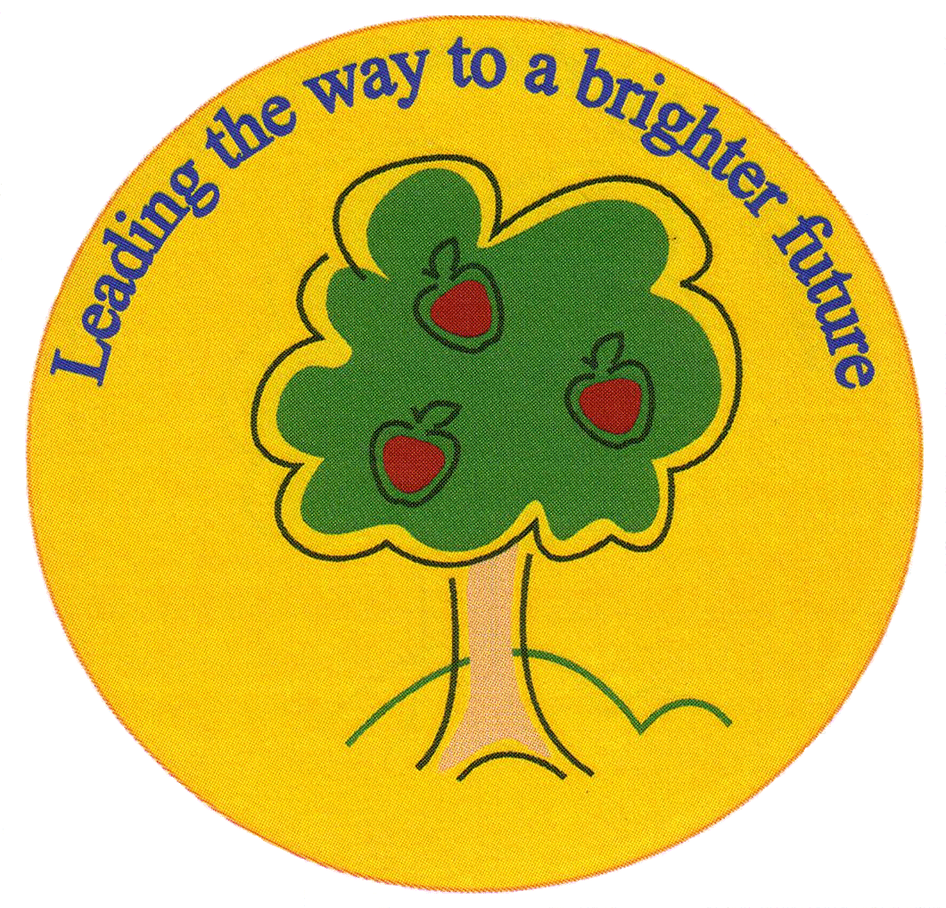
Fulfen Primary School
Rugeley Road
BURNTWOOD
Staffordshire
WS7 9BJ

Telephone: 01543 510400
Facsimile: 01543 510405
E-mail: Office @fulfen.staffs.sch.uk

Headteacher: Miss Jane Davies

17th September 2018
Dear Parents/Carers,
On Thursday 18th October, Year 6 will be going to Chase Terrace Technology College to take part in a joint English project. The children will be working with high school English teachers and Year 7 and 8 pupils. This will be an opportunity for the children to experience life at secondary school, as well as inspiring them to produce some high quality, purposeful writing before and after the visit.
We will be walking to Chase Terrace after lunch and we will be returning by the end of the school day. There is no charge for this trip. Children must ensure they have their inhalers with them, if needed, and to bring a coat with them on this day.
As part of this exciting project, the staff at CTTC have asked if we they can take photographs of the children to put on their website.
Please return the permission slip by Friday 12th October.
Thank you and best wishes,
Miss Greenfield and Mr Mennell
……………………………………………………………………………………………………………………………………………………………………………………….
CTTC Visit 18th October 2018

I give permission for _________________ (child’s name) to visit CTTC on 18.10.18.

I do/do not* give permission for _____________(child’s name) to have their photograph taken and this be displayed on the CTTC website.

Signed _____________________________ (parent/carer signature)
*Please circle your choice

