We are having a non-uniform day at Fulfen. The children can come to school dressed in casual clothing. They could also wear something red or even dye their hair red if they wanted to.

We are asking for a donation of £1 for the non-uniform day which we will collect in buckets on your way into school. All the money collected will be donated by the school to Comic Relief.

We will be selling red noses in the classrooms only from Monday 15th March, they are priced at £1.50 each and all the money charged goes to Comic Relief. They will not be available from the office

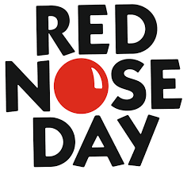

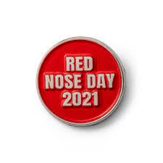

Fulfen are supporting Comic Relief again this year on

FRIDAY 19th MARCH